

|  |  |
| --- | --- |
| Student name: | Aldiyar Kyzyrkhanov, Kurmanbay Abilkaiyr, Petr Tsekoyev |
| Group name: | CS-2113, CS-2114, CS-2107 |
| Teacher name: | Arailym Tleubayeva |
| Project name: | OSC Final Project - Report |
| Project type: | Group (3 Participants) |
| Number of words | ~1500 |

*https://github.com/Aldikkaiupov/final-os*

**List Of Figures**

1. Introduction

1.1. The outline of the project3

2. Main part

2.1. Task 1 – Adding new user5

2.2. Task 2 – Adding 3 Methods of Connecting to Internet5

2.2.1. Direct IP connection5

2.2.2. NAT eth0 and eth1 connection5

2.2.3. Proxy connection5

2.3. Task 3 – Linux Kernel5

2.3.1. Compiling custom Linux Kernel5

2.3.2. Making custom Linux Kernel Modules5

3. Conclusion

3.1. Reflection and summary18

4. References and bibliography materials

**1. Introduction**

**1.1. The outline of the project**

This report of final project tasks describes the completion of three tasks which related to Operation Systems Concepts course and basics of Linux System Administration. It includes an algorithms or methods for solving this specific problems, the results of the completed task with screenshots, also demonstrates the team's understanding and practical skills, conclusion findings. Tasks were completed by a team of 5 students and report was created in PDF format.

Task 1 involves adding a new user to the Ubuntu system. Task 2 focuses on connecting to the Internet using different methods such as a direct IP connection, NAT, and a proxy server. Task 3 involves developing a Linux Kernel module with basic Kernel structure. We will use Microsoft Azure for hosting proxy server and Squid-cache for caching proxy of HTTPS, HTTP, etc. types of connections. Moreover, we will implement many types of Linux Kernel deployment with bash, git, mainline and so on.

**2. Main Part**

**2.1. Task 1 – Adding new user**

In this task we need to add new user to our Ubuntu Linux OS. Firstly, writing “sudo adduser student” to add new user (username “student”, password “student”). Secondly, adding to this user sudo root permissions (“administrator permissions”). Thirdly, we need to login as that user.

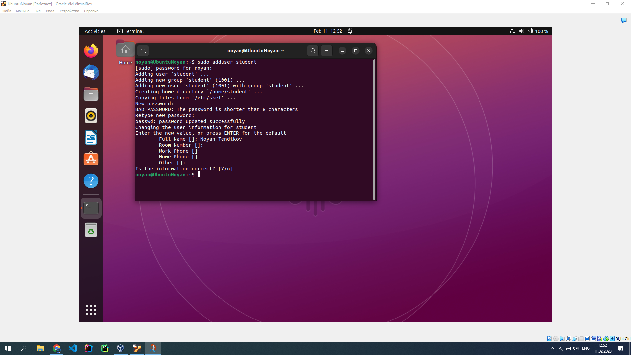

Picture 1. Creating new user “student” with password “student” – sudo adduser student.



Picture 2. Adding to this user sudo root permissions (“administrator permissions”).

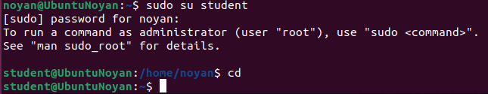

Picture 3. sudo su student – to login as user.

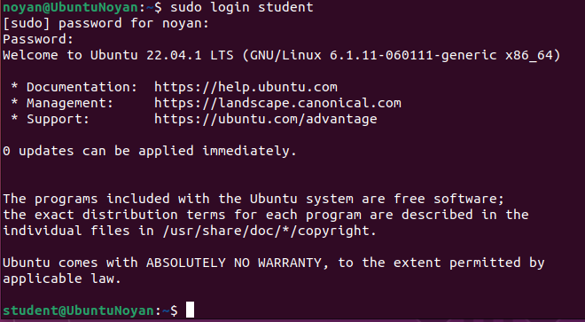

Picture 4. sudo login student- same as sudo su student.

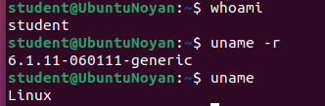

Picture 5. whoami – checking what user we are.

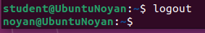

Picture 6. logout – logging out from user “student” to main user “noyan”.

**2.2. Task 2 – Adding 3 Methods of Connecting to Internet**

**2.2.1. Direct IP connection**

This type of internet connection requires that the VM is assigned direct IP address or DHCP address on the Internet. It allows to communicate directly with other devices on the Internet or Local Area. So, we did following steps: installed network-manager with dhcpcd, powered on DHCP connection on enp03s, and checked it.

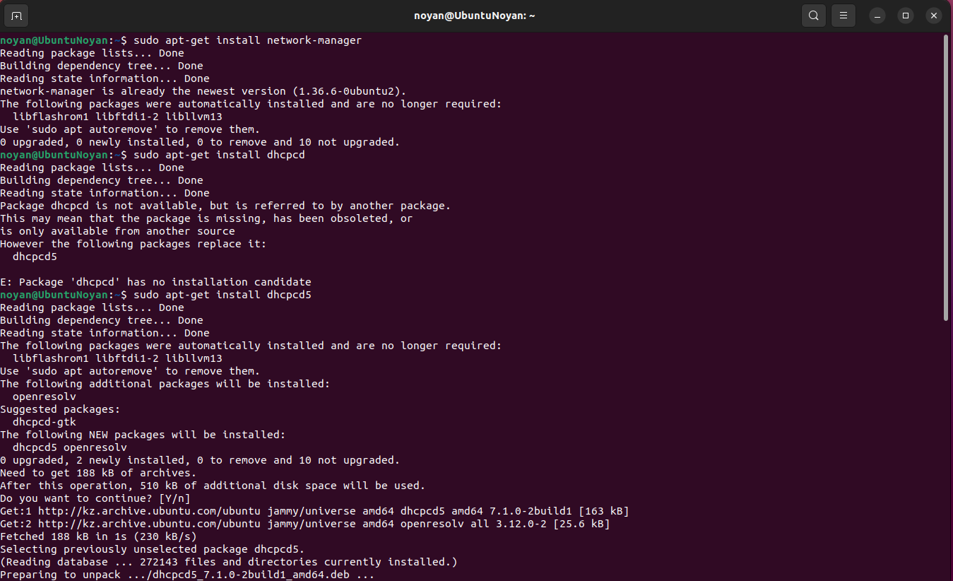

Picture 1. Installing network-manager with dhcpcd packets.

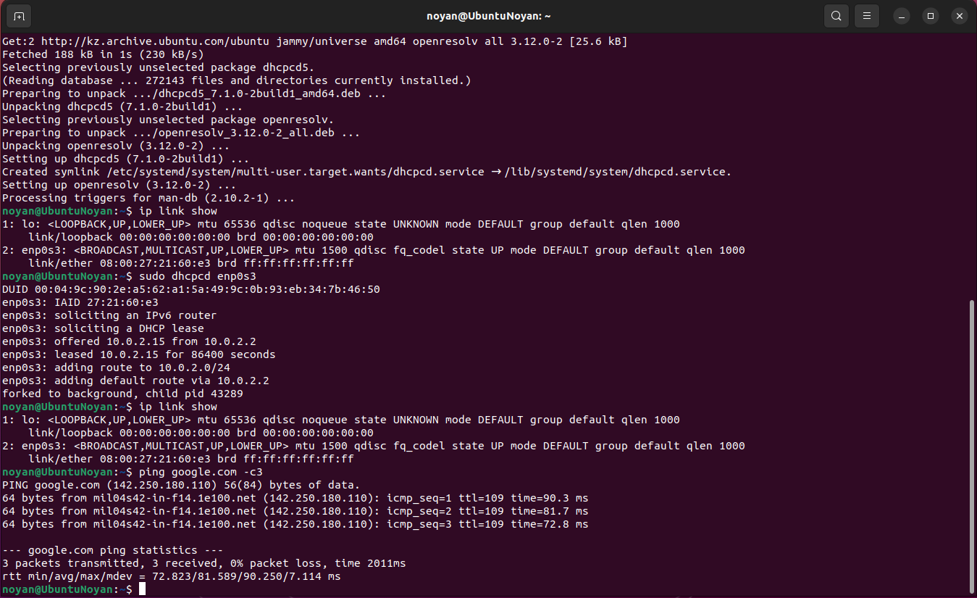

Picture 2. Adding DHCP connection to enp0s3, then checking this by pinging services (google.com).

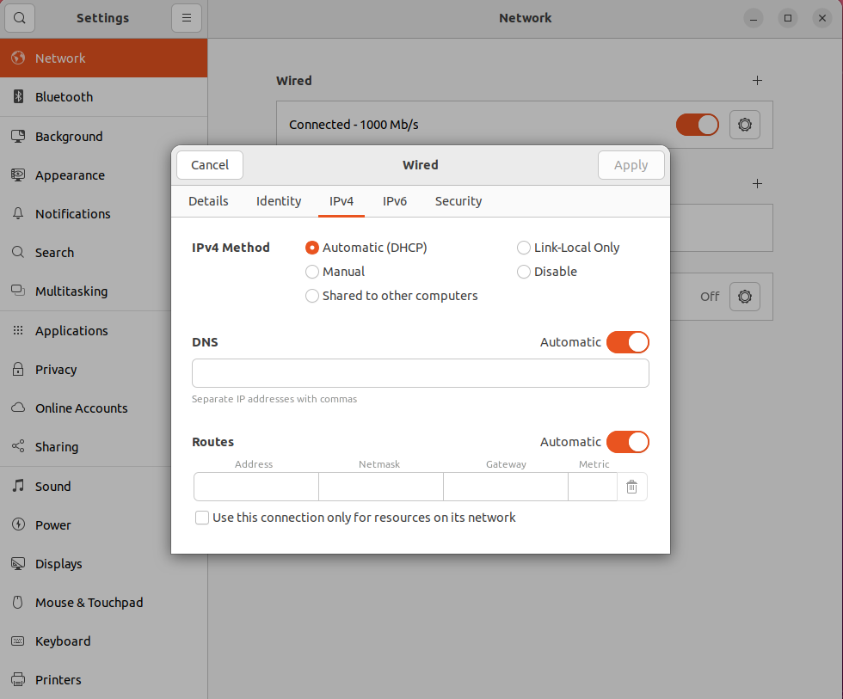

Picture 3. This is the way how to make this procedure with GUI of Ubuntu.

**2.2.2. NAT eth0 and eth1 connection**

NAT – method of remapping IP addresses spaces into another by modifying information in IP headers while transferring across traffic. We did NAT set up with using iptables, their firewall allows to you set up control of traffic.

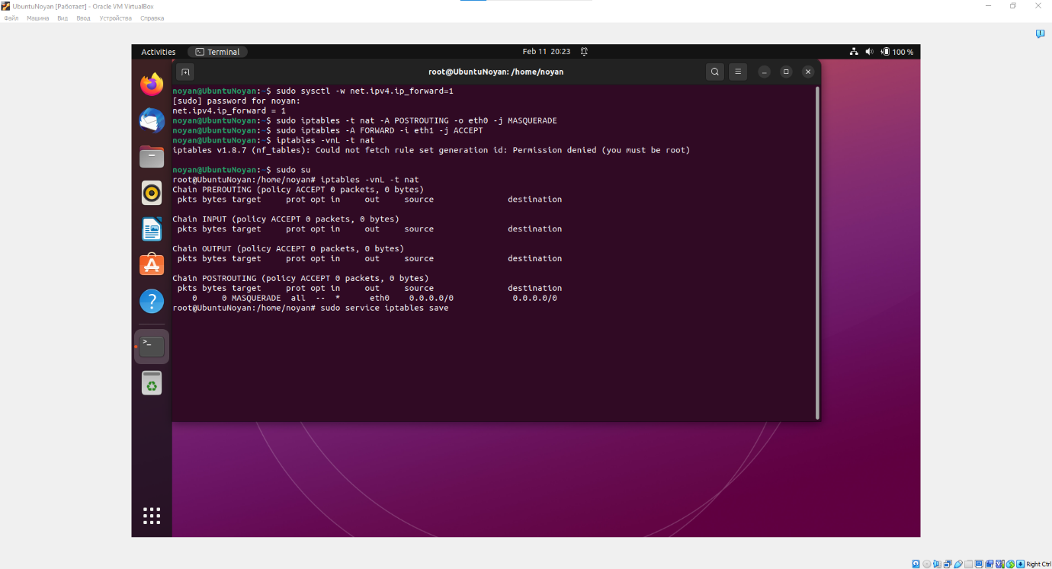

Picture 1. Enable IP forwarding, so Linux can act as a virtual router.



Picture 2. Set up iptables NAT by creating two iptables rules. First rule about translating incoming traffic from the external interface (eth0) to the internal interface (eth1). Second rule about accepting incoming traffic from the internal interface (eth1).



Picture 3. Checking out NAT iptables and saving them.

**2.2.3. Proxy connection**

Proxy server – application program or system that acts as an intermediary for requests from clients seeking resources from servers. It provides a way to access internet pages indirectly, through middle server. So, we can bypass censorships, firewalls, bans, hiding IP address, security data. We used Microsoft Azure for hosting Linux Ubuntu server with Squid-caches, then we added OpenDNS with Pi-Hole.

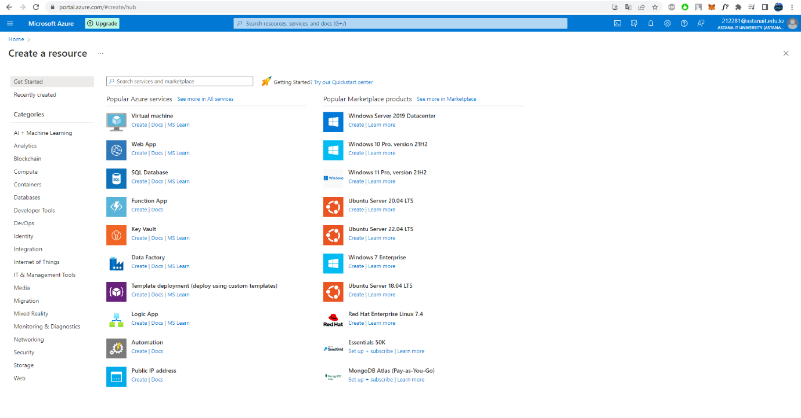

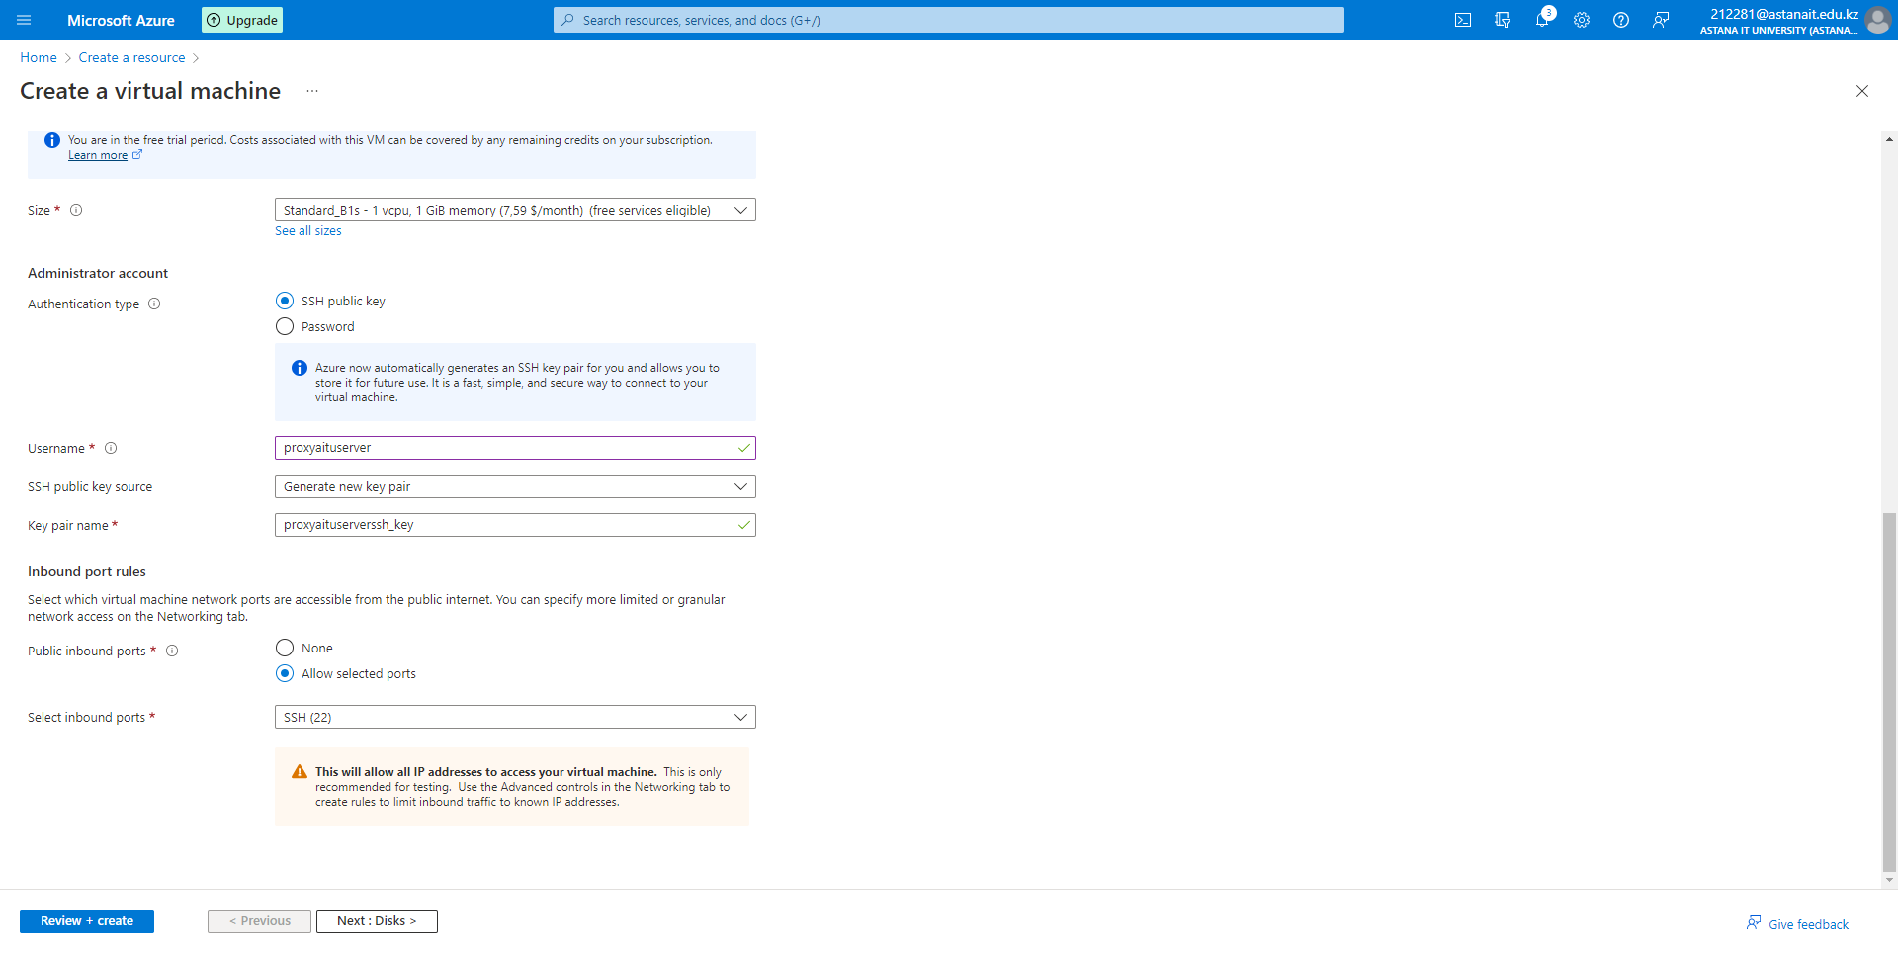****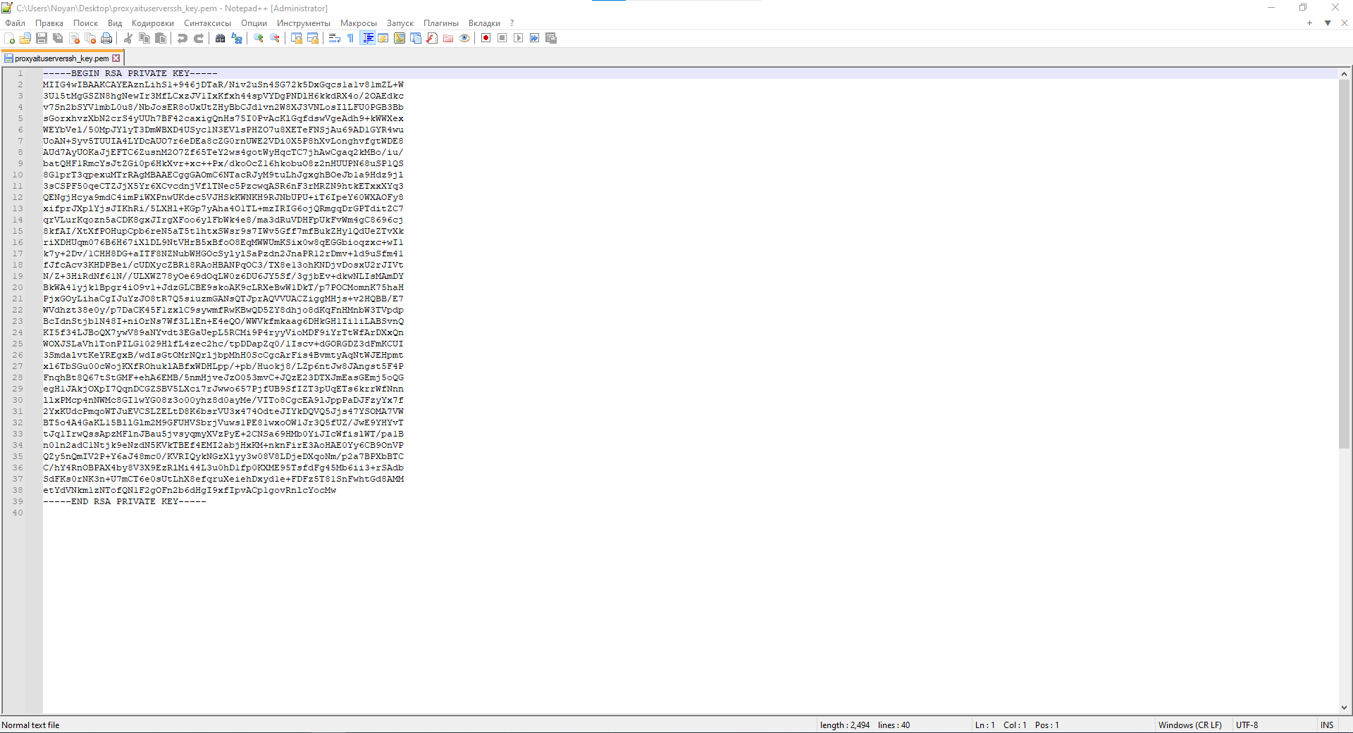

Picture 1. Deploying Linux Ubuntu 22.04 LTS server (username proxyaituserver, ssh key auth file).

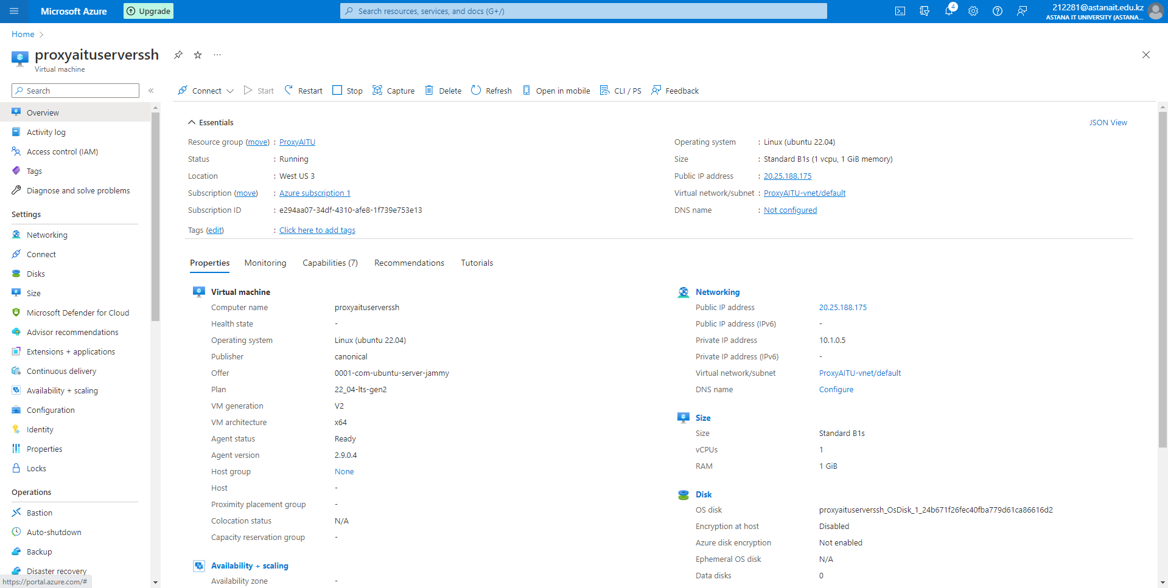

Picture 2. Brief information of our server (Public IP, Private IP, OS, etc.).

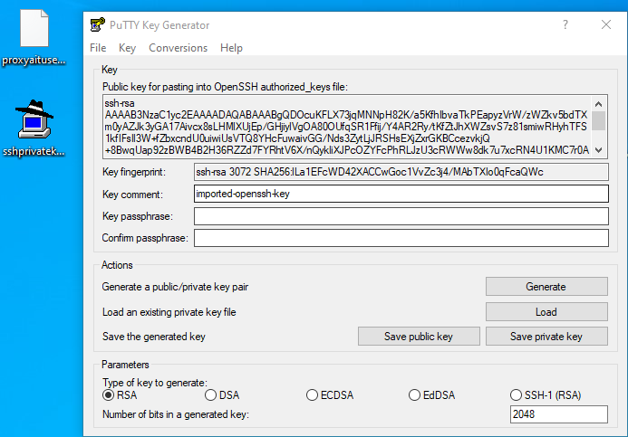

Picture 3. PuTTY key translator from ssh to ssh-rsa.

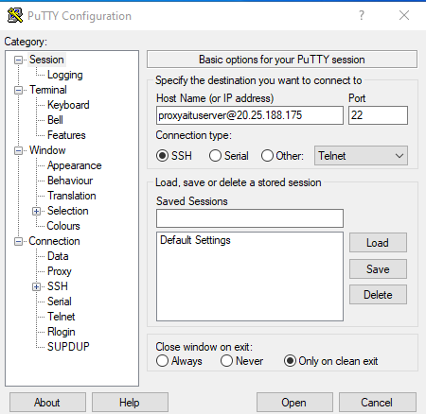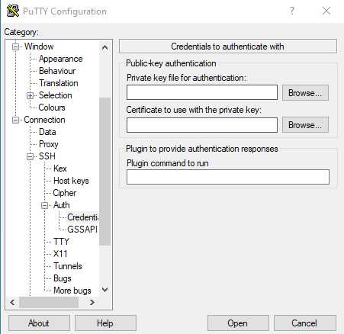

Picture 4. Connecting to server via ssh-rsa key (hostname [proxyaituserver@20.25.188.175:22](mailto:proxyaituserver@20.25.188.175:22)).

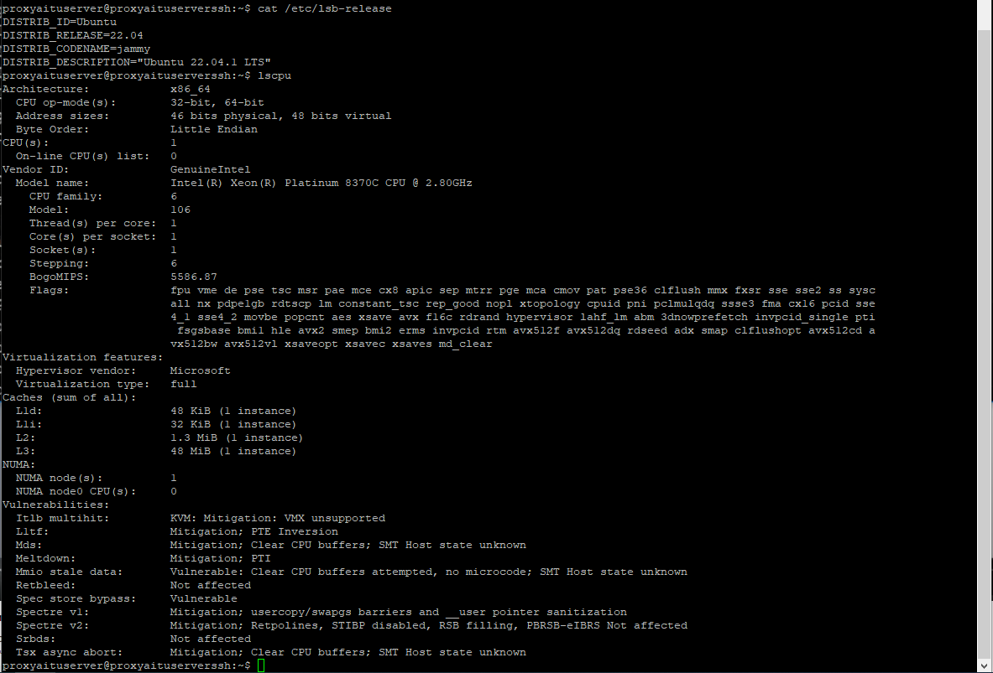

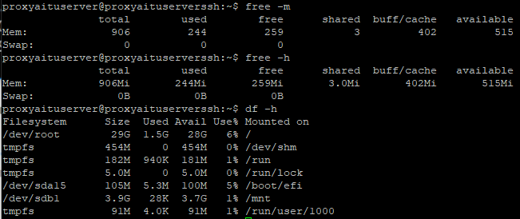

Picture 5. Checking real configuration of our server.

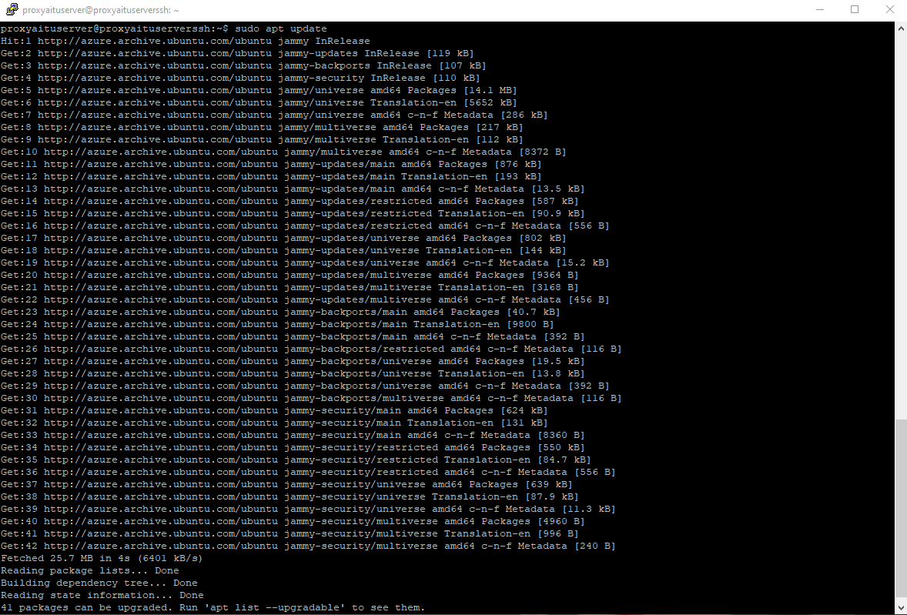

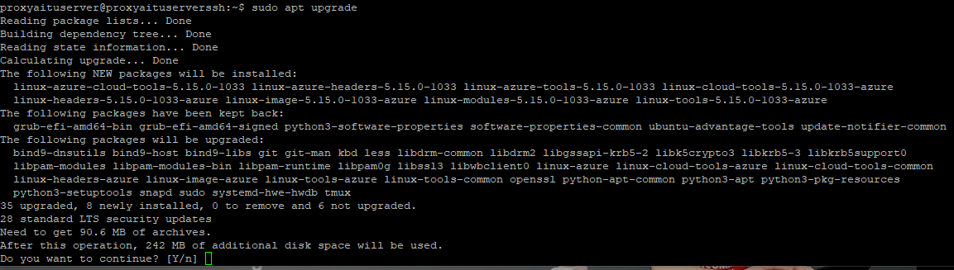

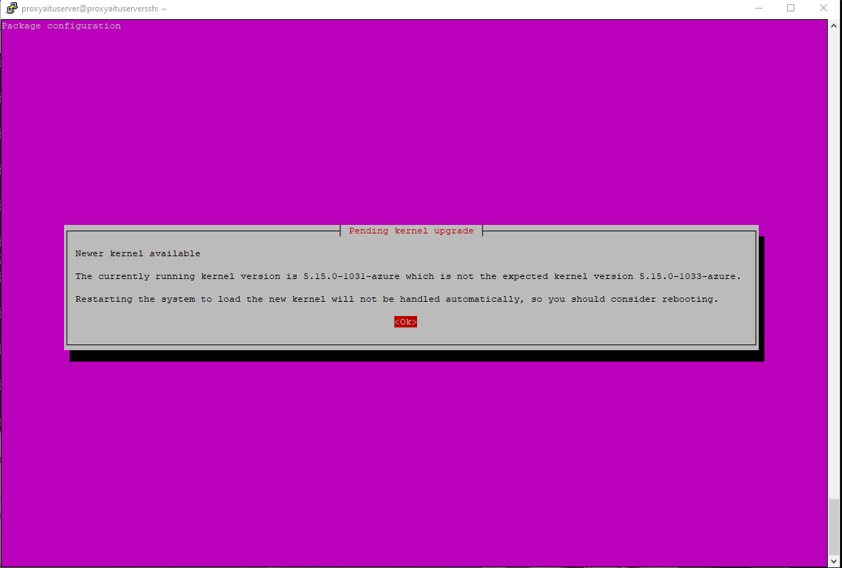

Picture 6. Installing and upgrading last version of system packets with linux kernel (sudo apt update, sudo apt upgrade).

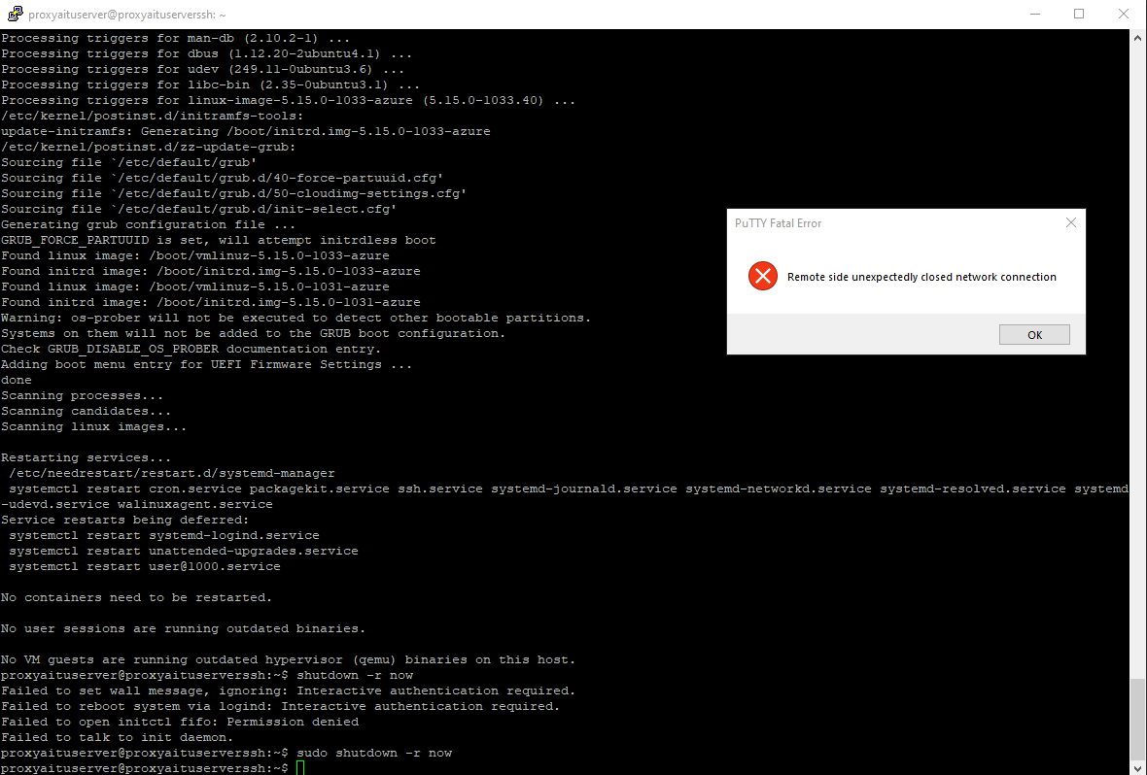

Picture 7. Then we need to reload server to boot new kernel as well.

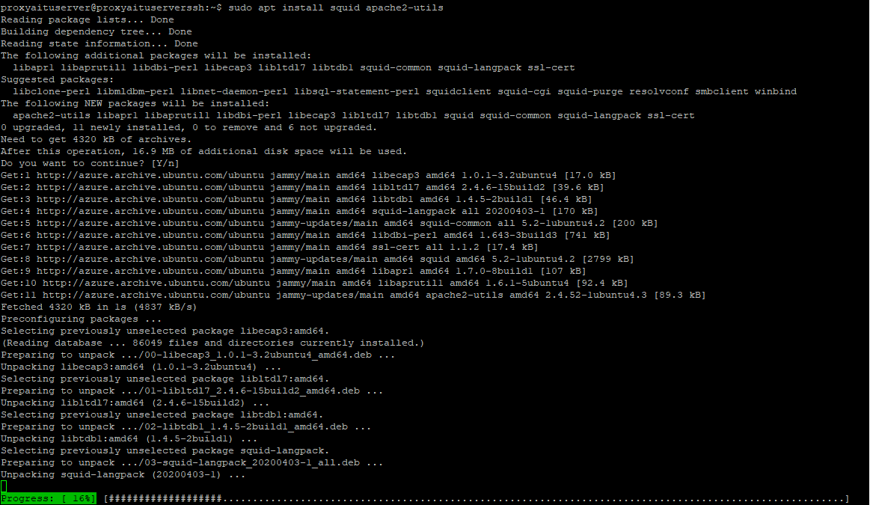

Picture 8. Installing squid-cache for proxy settings and apache2-utils for user authorization.

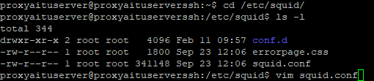

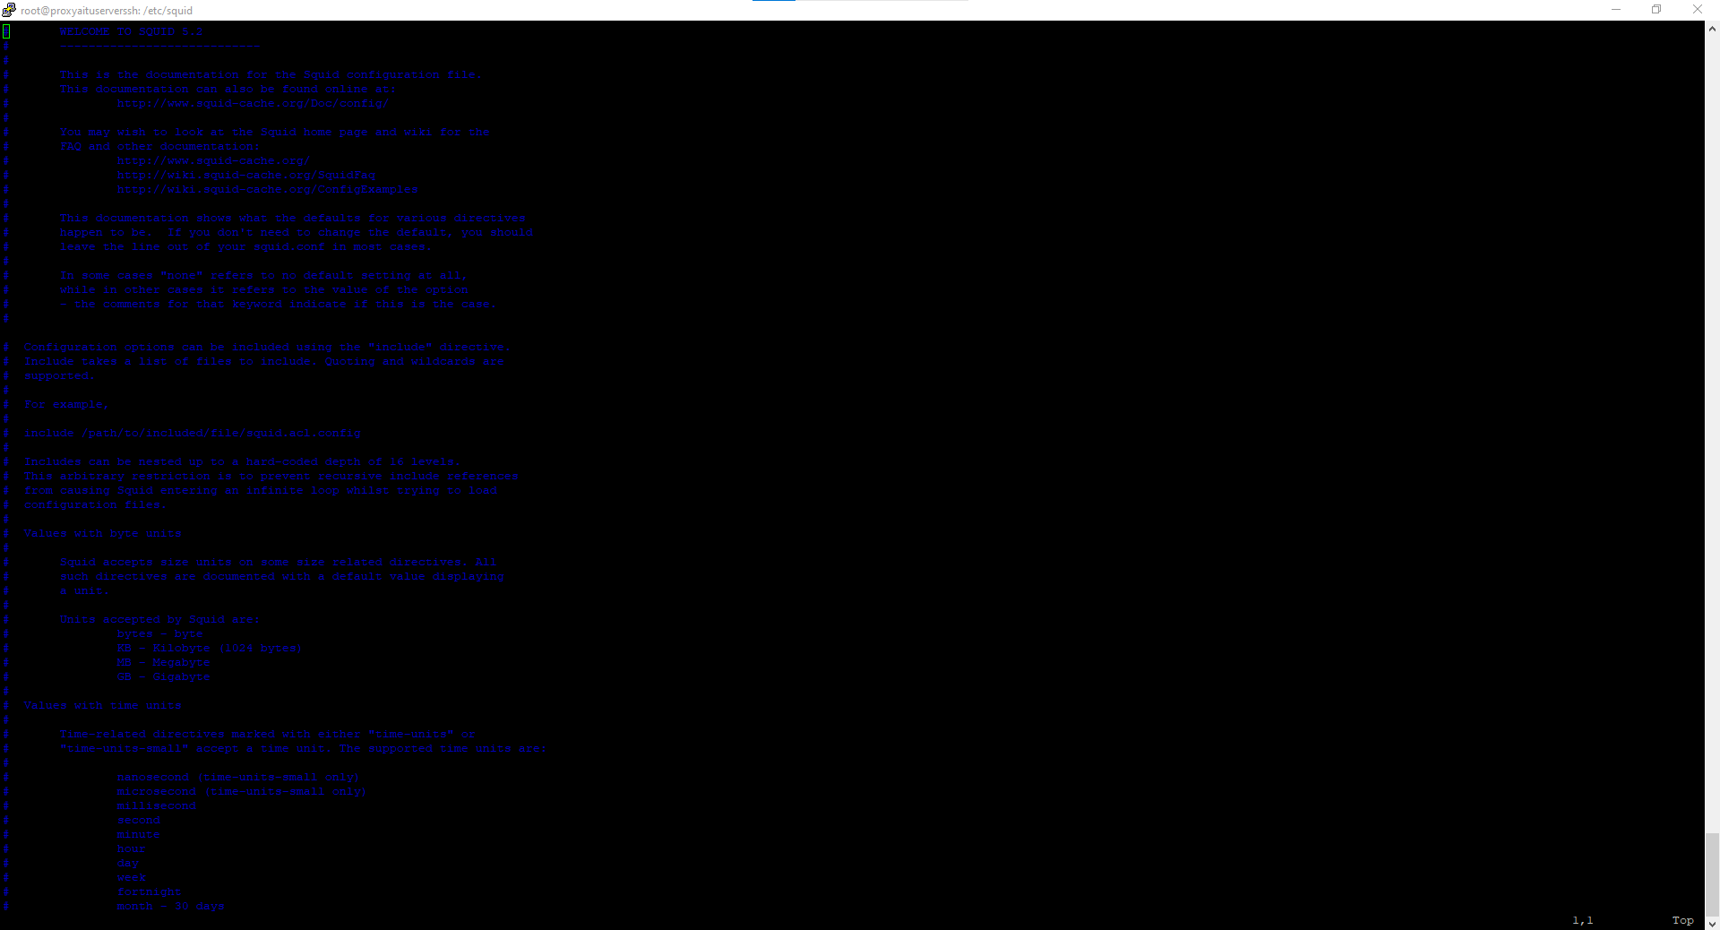

Picture 9. In /etc/squid/squid.conf we have basic configuration of proxy connection or filters, therefore need to write personal custom configuration.

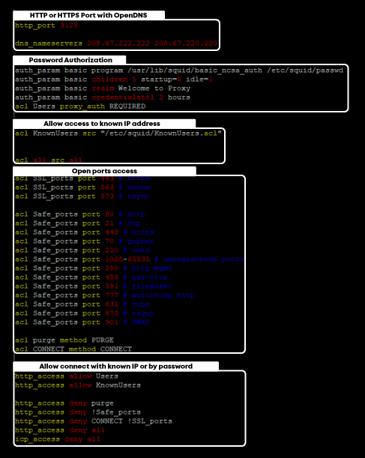

Picture 10. First part of our custom-made proxy squid.conf file.

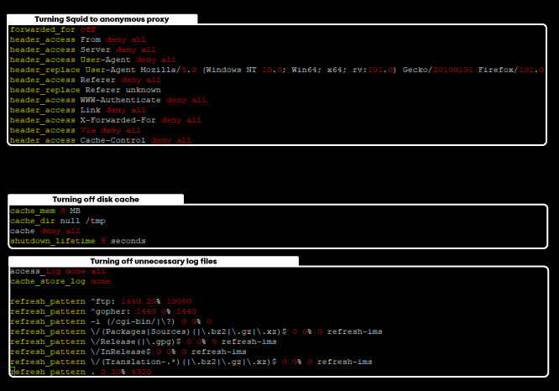

Picture 11. Second part of our custom-made proxy squid.conf file.

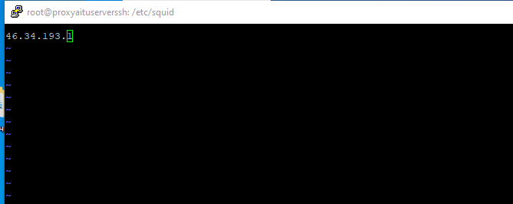

Picture 12. Adding our IP address to known IP (46.34.193.1).

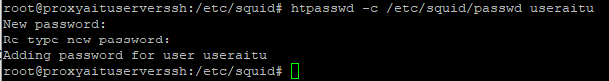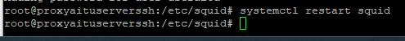

Picture 13. Creating new user (username useraitu, password aitucisco), also restarting proxy to start it working.

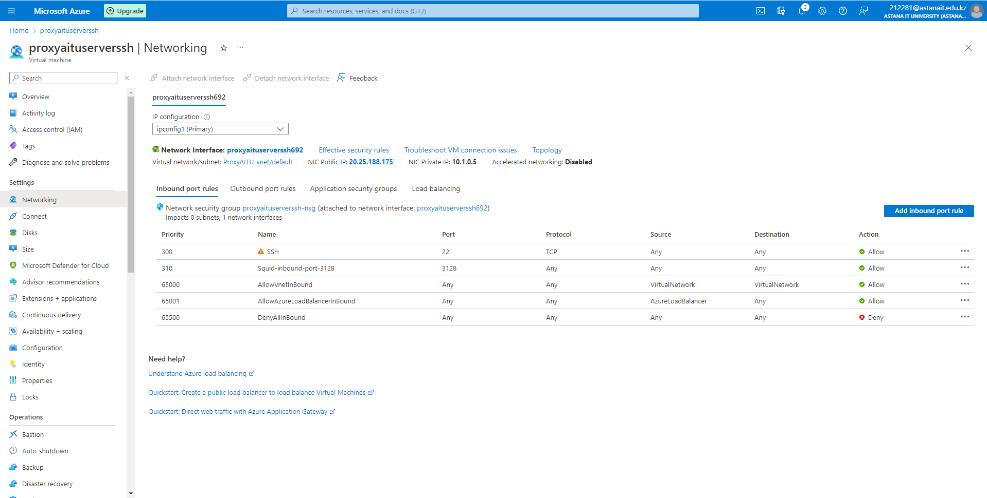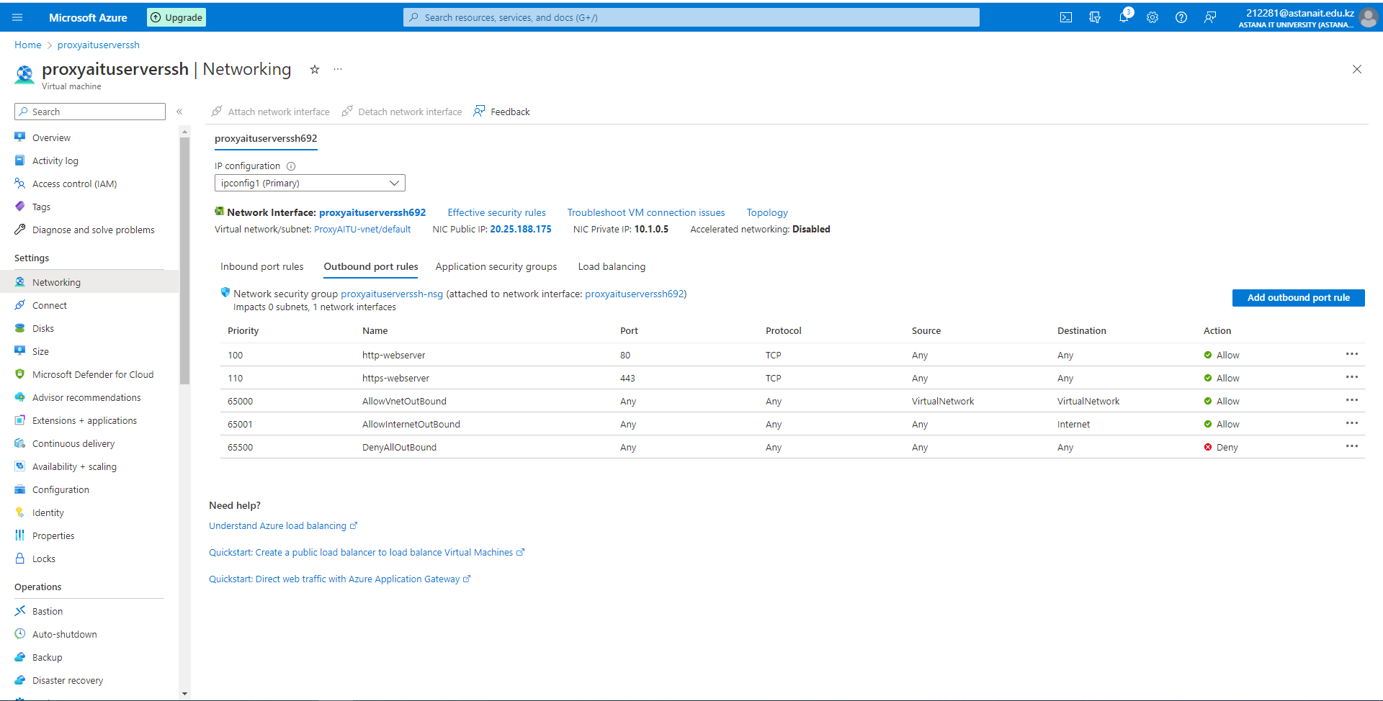

Picture 14. Making inbound and outbound rules for http or https connections of proxy port 3128.

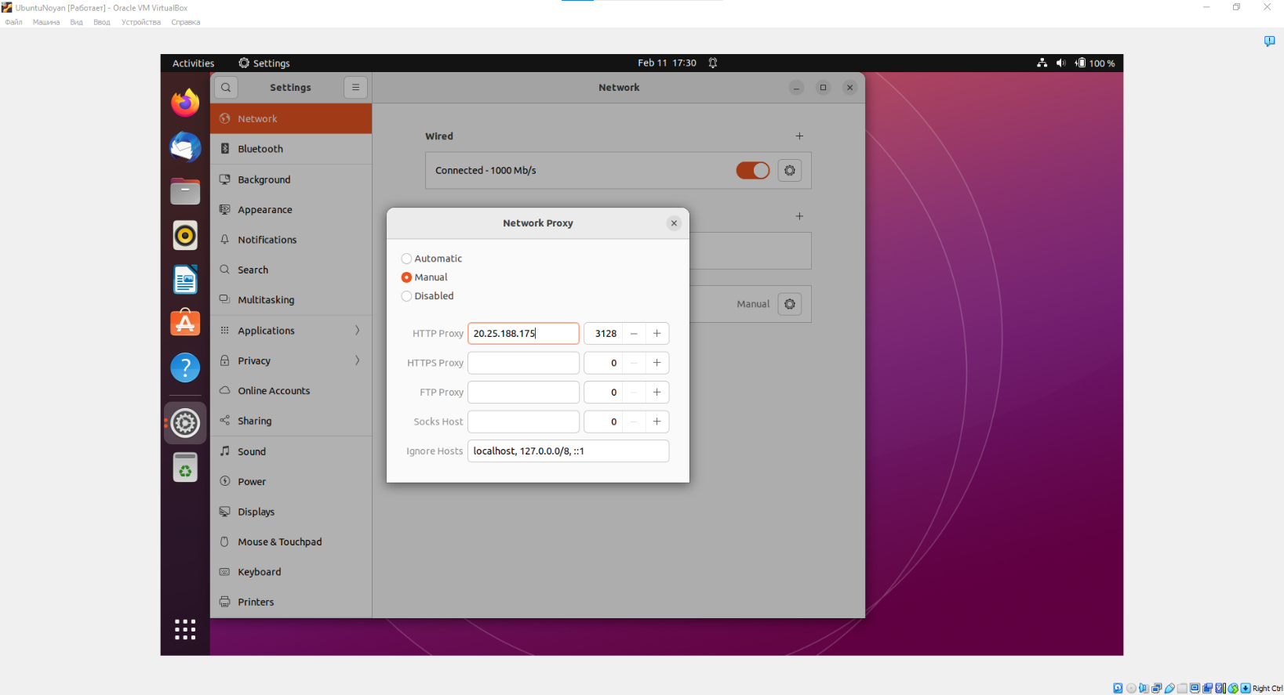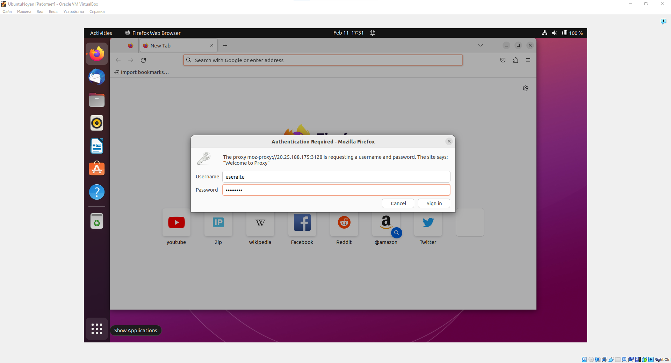

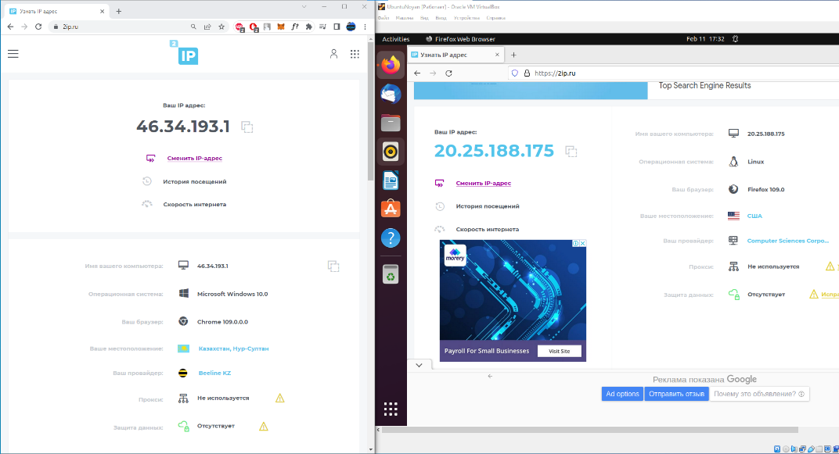

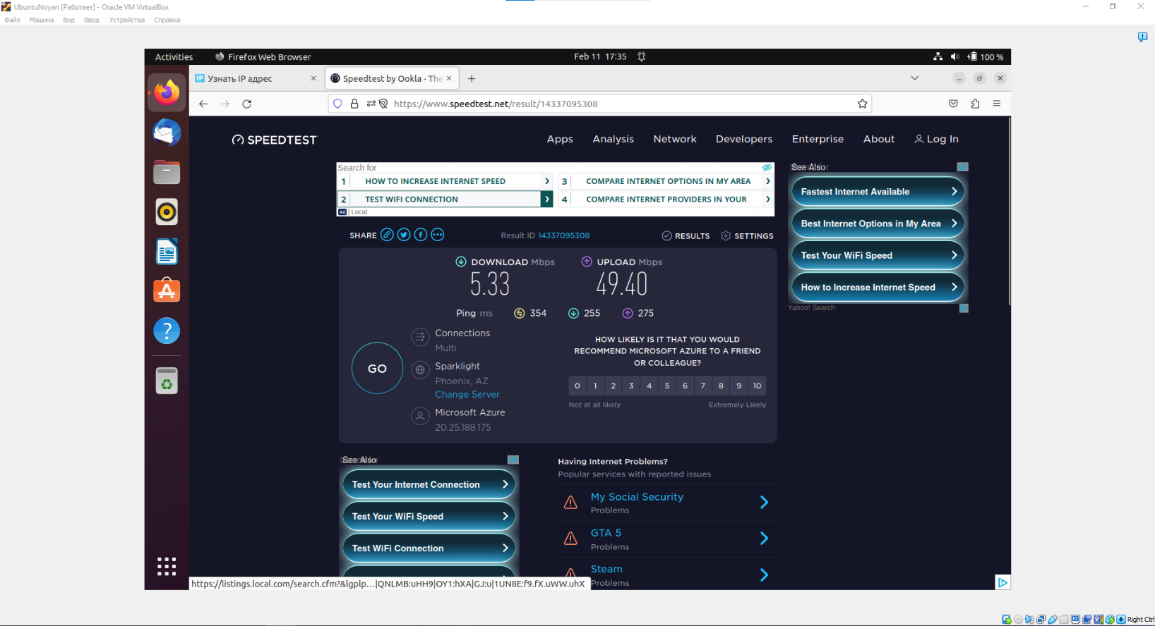

Picture 15. Checking proxy server connection (46.34.193.1 without proxy, 20.25.188.175 with proxy).



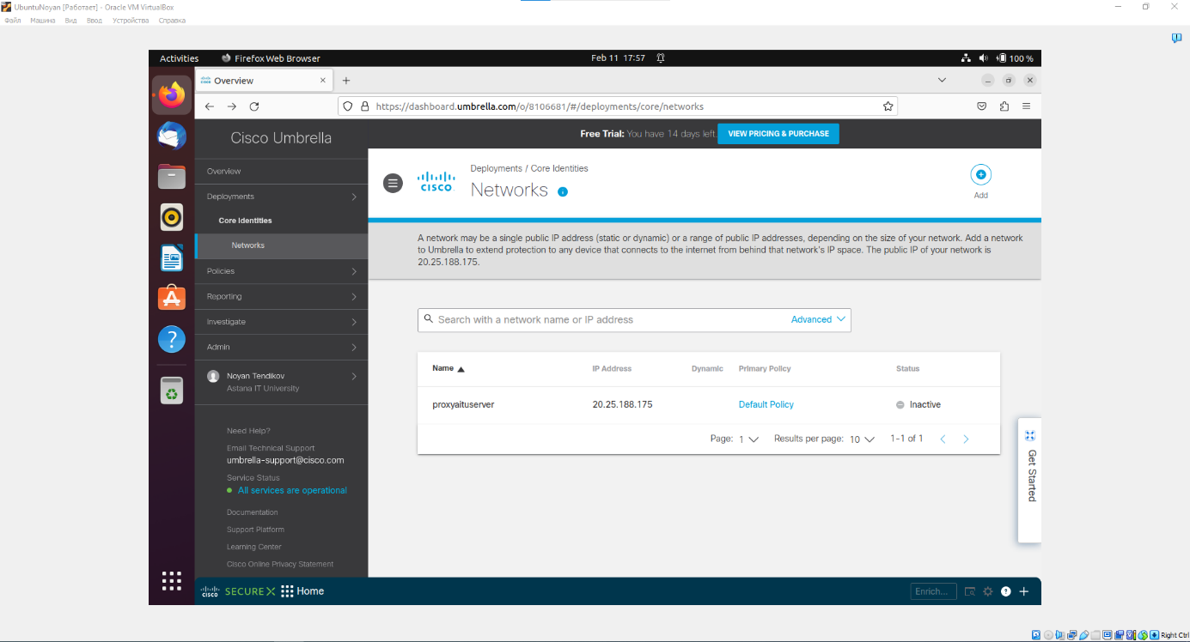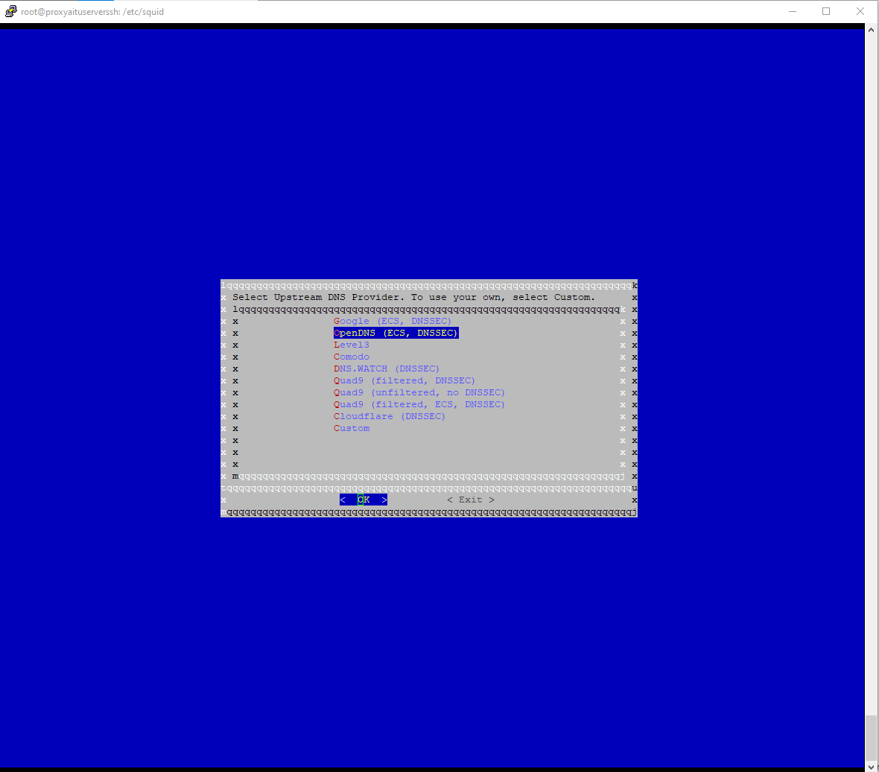

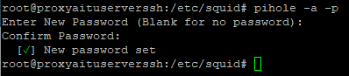

Picture 16. Building on Pi-Hole and OpenDNS Cisco to adblock connection for specific website or making firewall on proxy.

**2.3. Task 3 – Linux Kernel**

**2.3.1. Compiling custom Linux Kernel**

There are many types of Linux Kernel deployments or installations. We will cover only main of them: monolithic kernel via kernel archives and make oldconfig, custom kernel by make menuconfig, and kernel mainline.

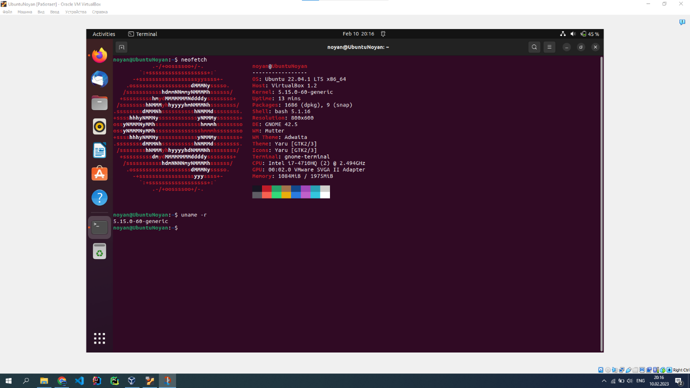

Picture 1. Checking our version of kernel with uname -r or neofetch (our current kernel 5.15.0-60-generic).

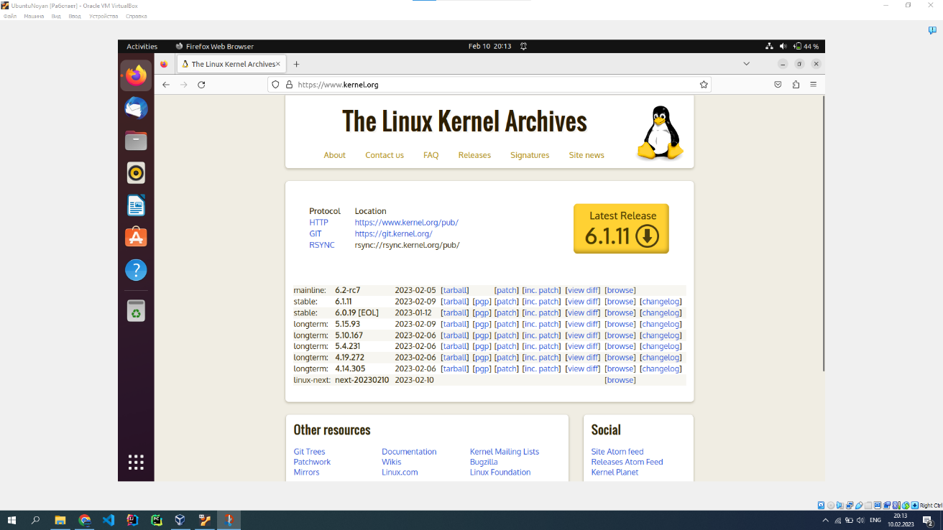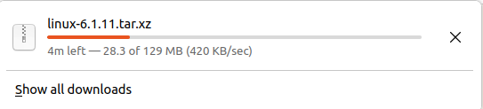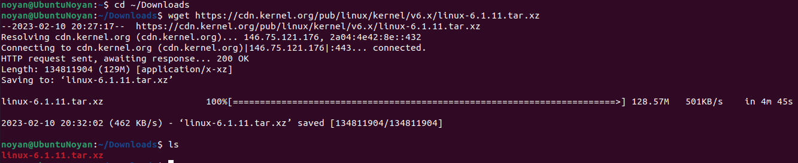

Picture 2. Going to Linux Kernel Archives, we need to download only stable release (now it is 6.1.11). We can download kernel image manually or with bash wget or git.



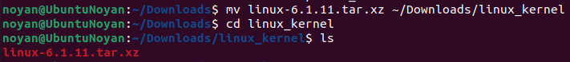



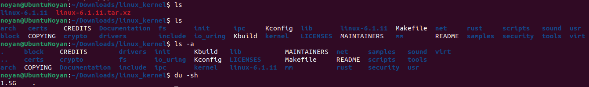

Picture 3. Unzipping linux kernel image to dir linux_kernel in ~/Downloads.

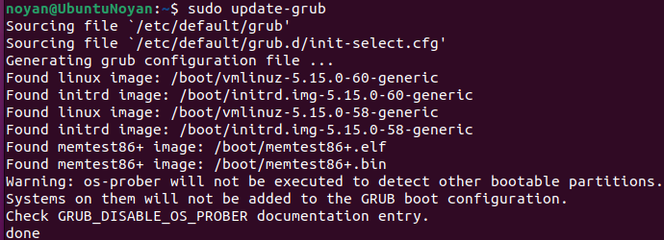

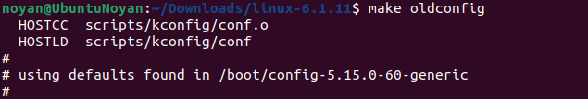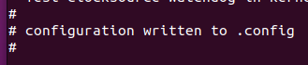



Picture 4. This is the way of installation of Linux Kernel based on make oldconfig or make olderconfig.



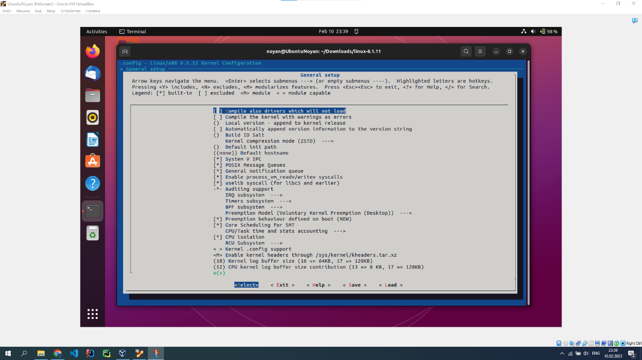

Picture 4. This is how to make installation of Linux Kernel with make menuconfig. You need to configure every part of kernel (modules) step by step.

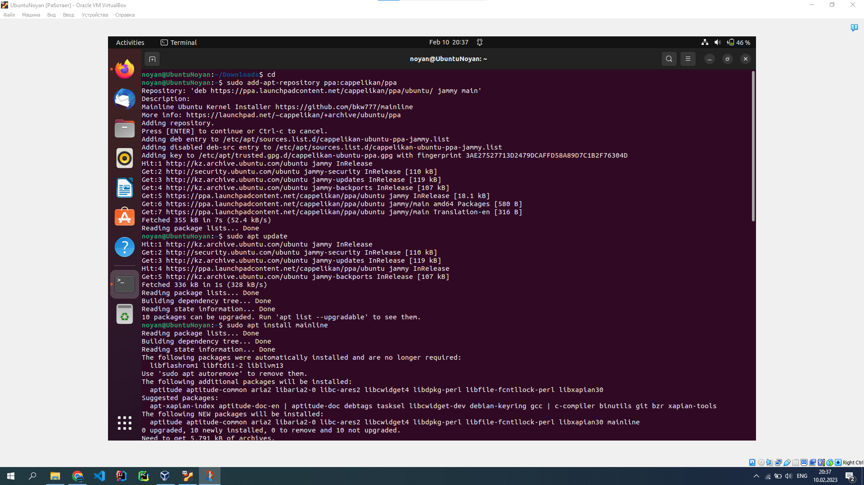





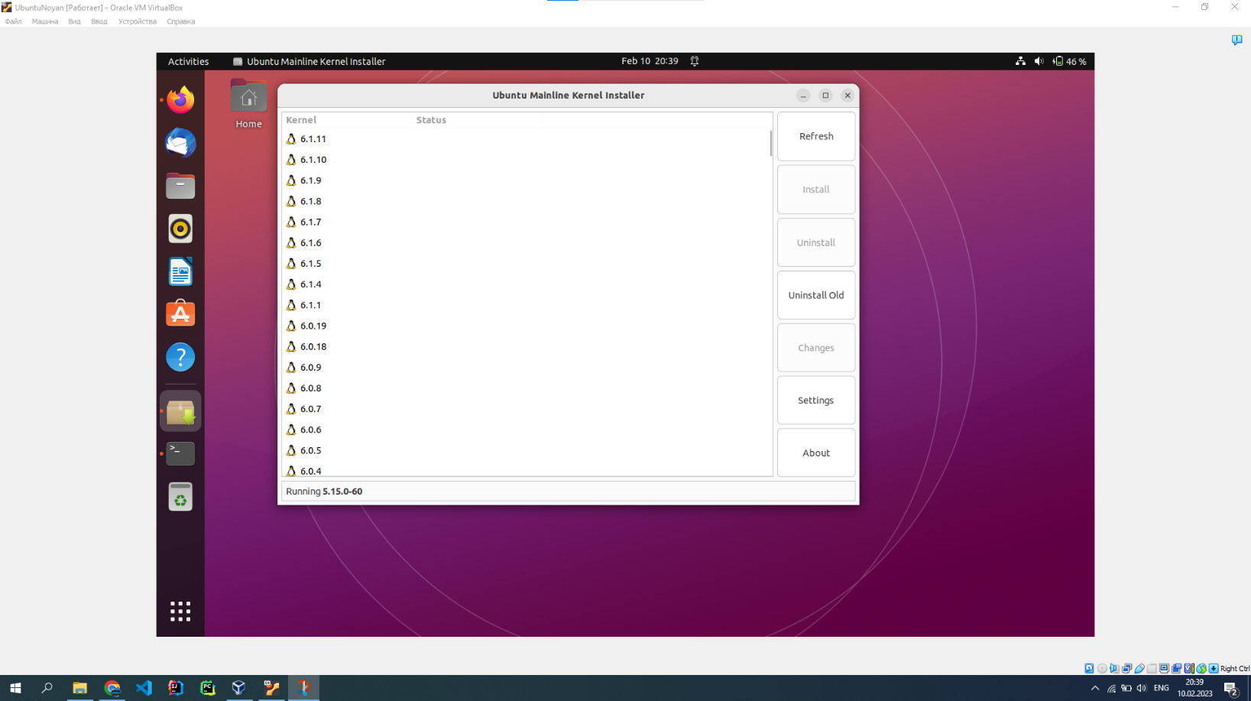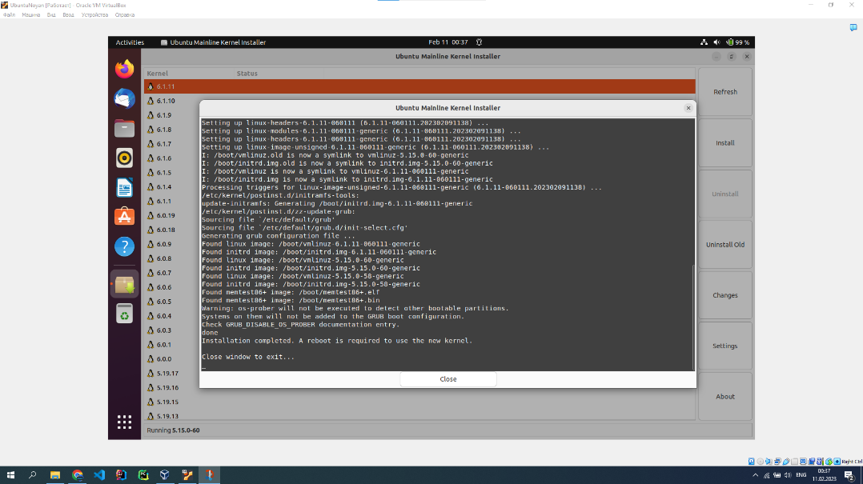

Picture 5. If you aren’t sure about quality of your installation or you don’t know how to do it, you can make it with mainline kernel installer.

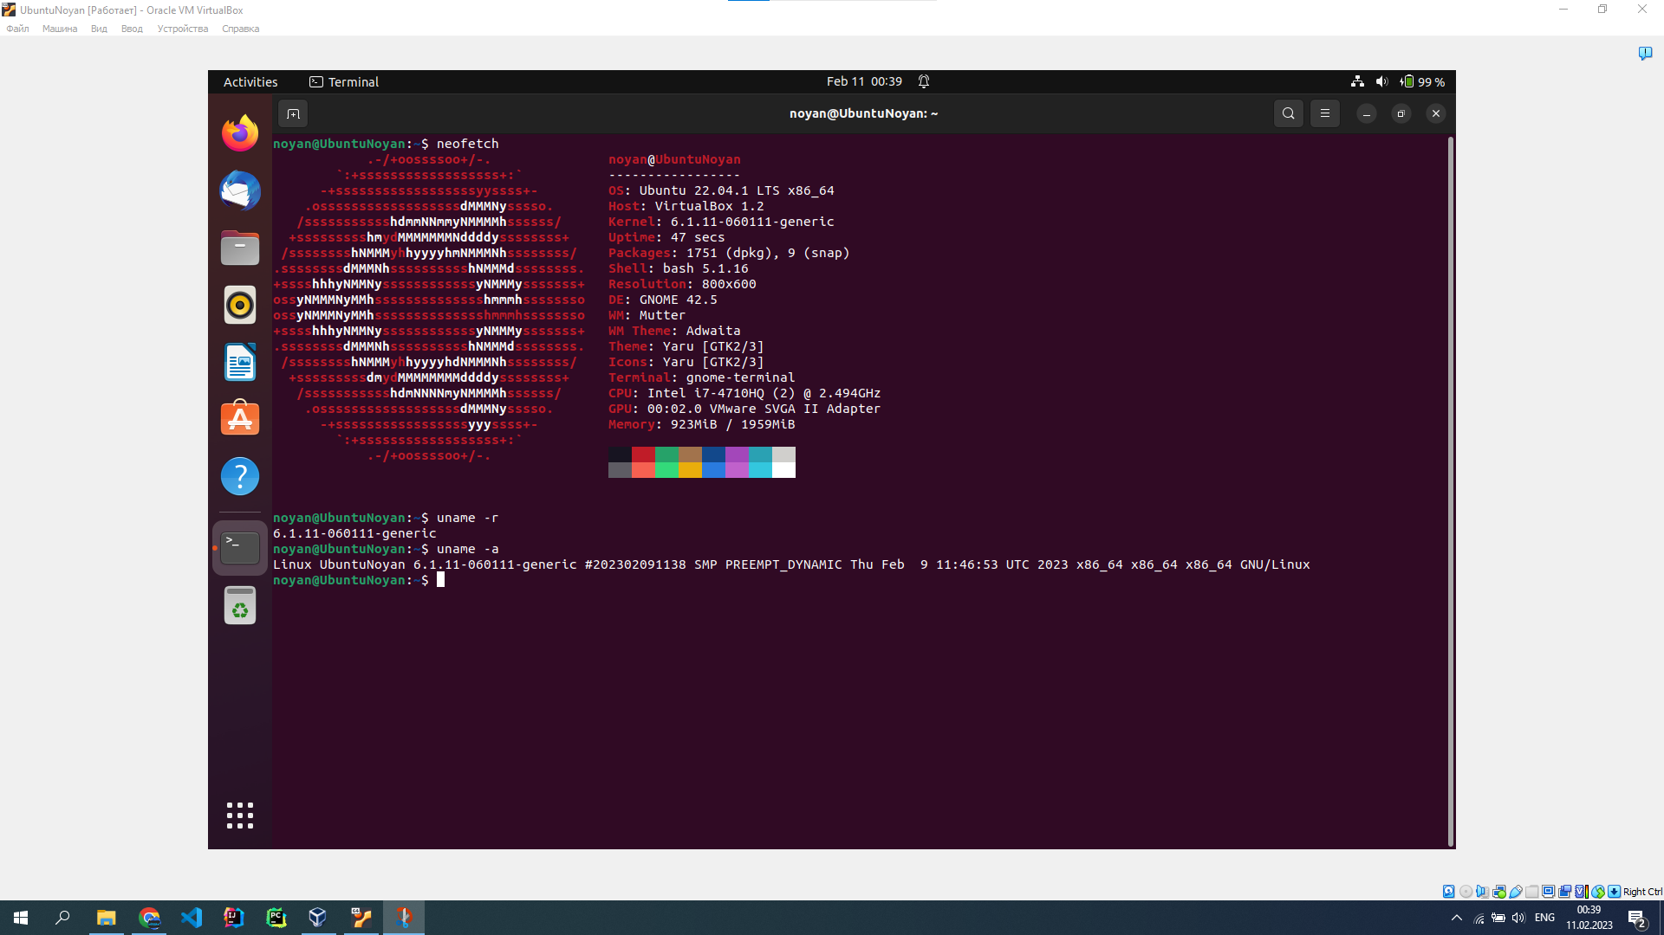

Picture 6. We tried all 3 methods of installing, so we got no problems with OS or Kernel stability (6.1.11 version).

**2.3.2. Compiling custom Linux Kernel**

Linux Kernel Modules – components of kernel which could be loaded or unloaded dynamically while OS is running. They provide additional functionality or support to hardware devices, files, system calls. Therefore, we developed our 3 simple useful kernel modules: “Current Timer Module”, “Hello World Module”, “Imitation Device Callbacks Module”. All modules code in our github of project (https://github.com/NoyanTM/osc-final-project).

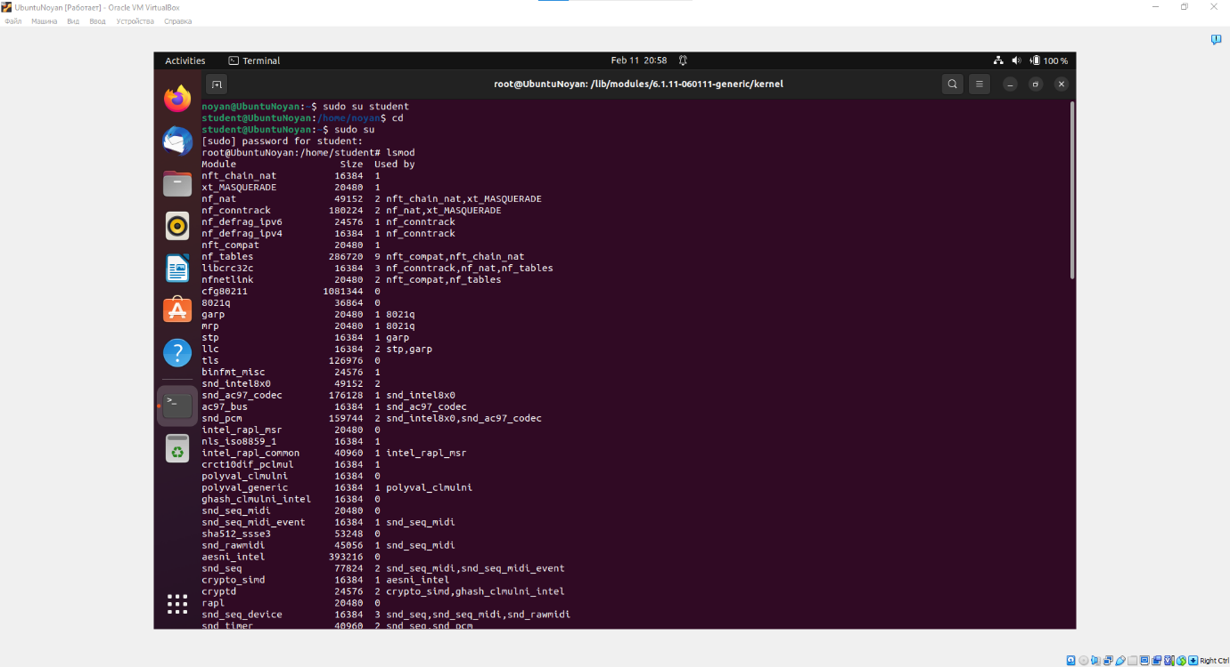

Picture 1. Searching for current active kernel modules – lsmod.

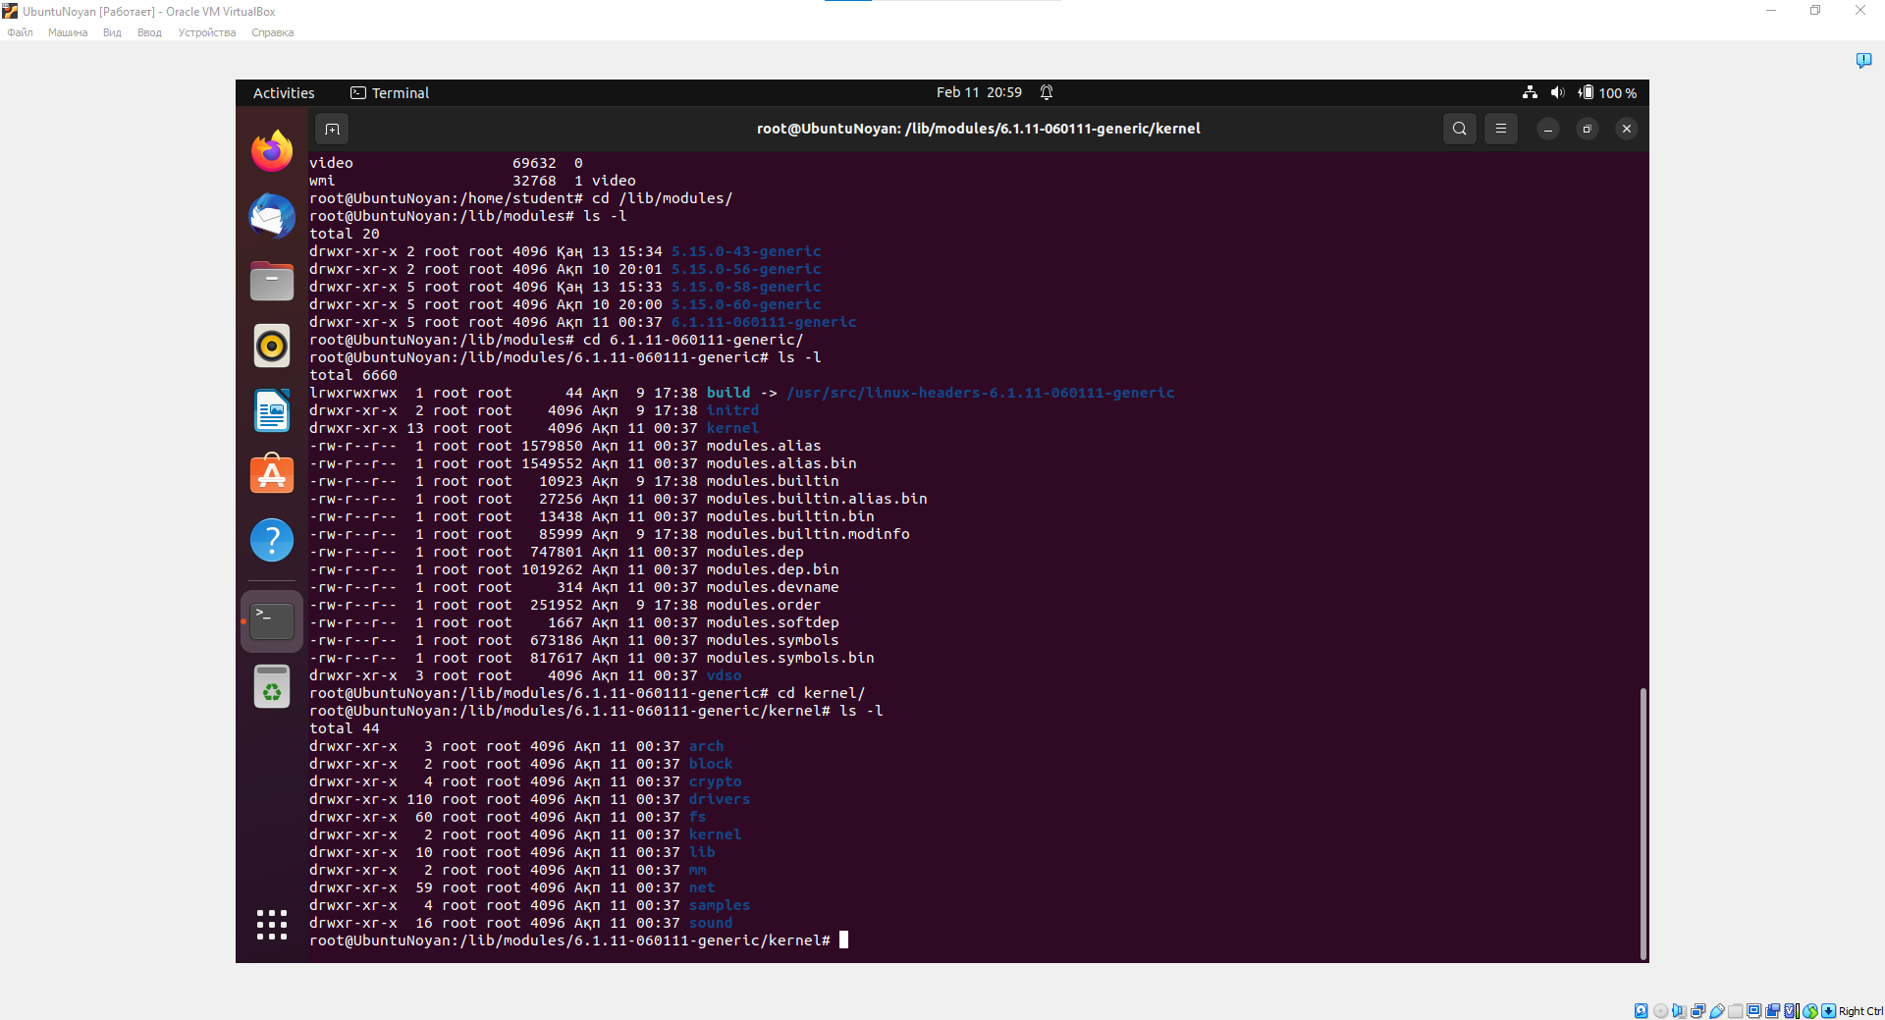

Picture 2. Types of main kernel modules types in Linux (arch, block, crypto, etc.).

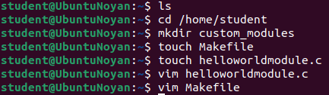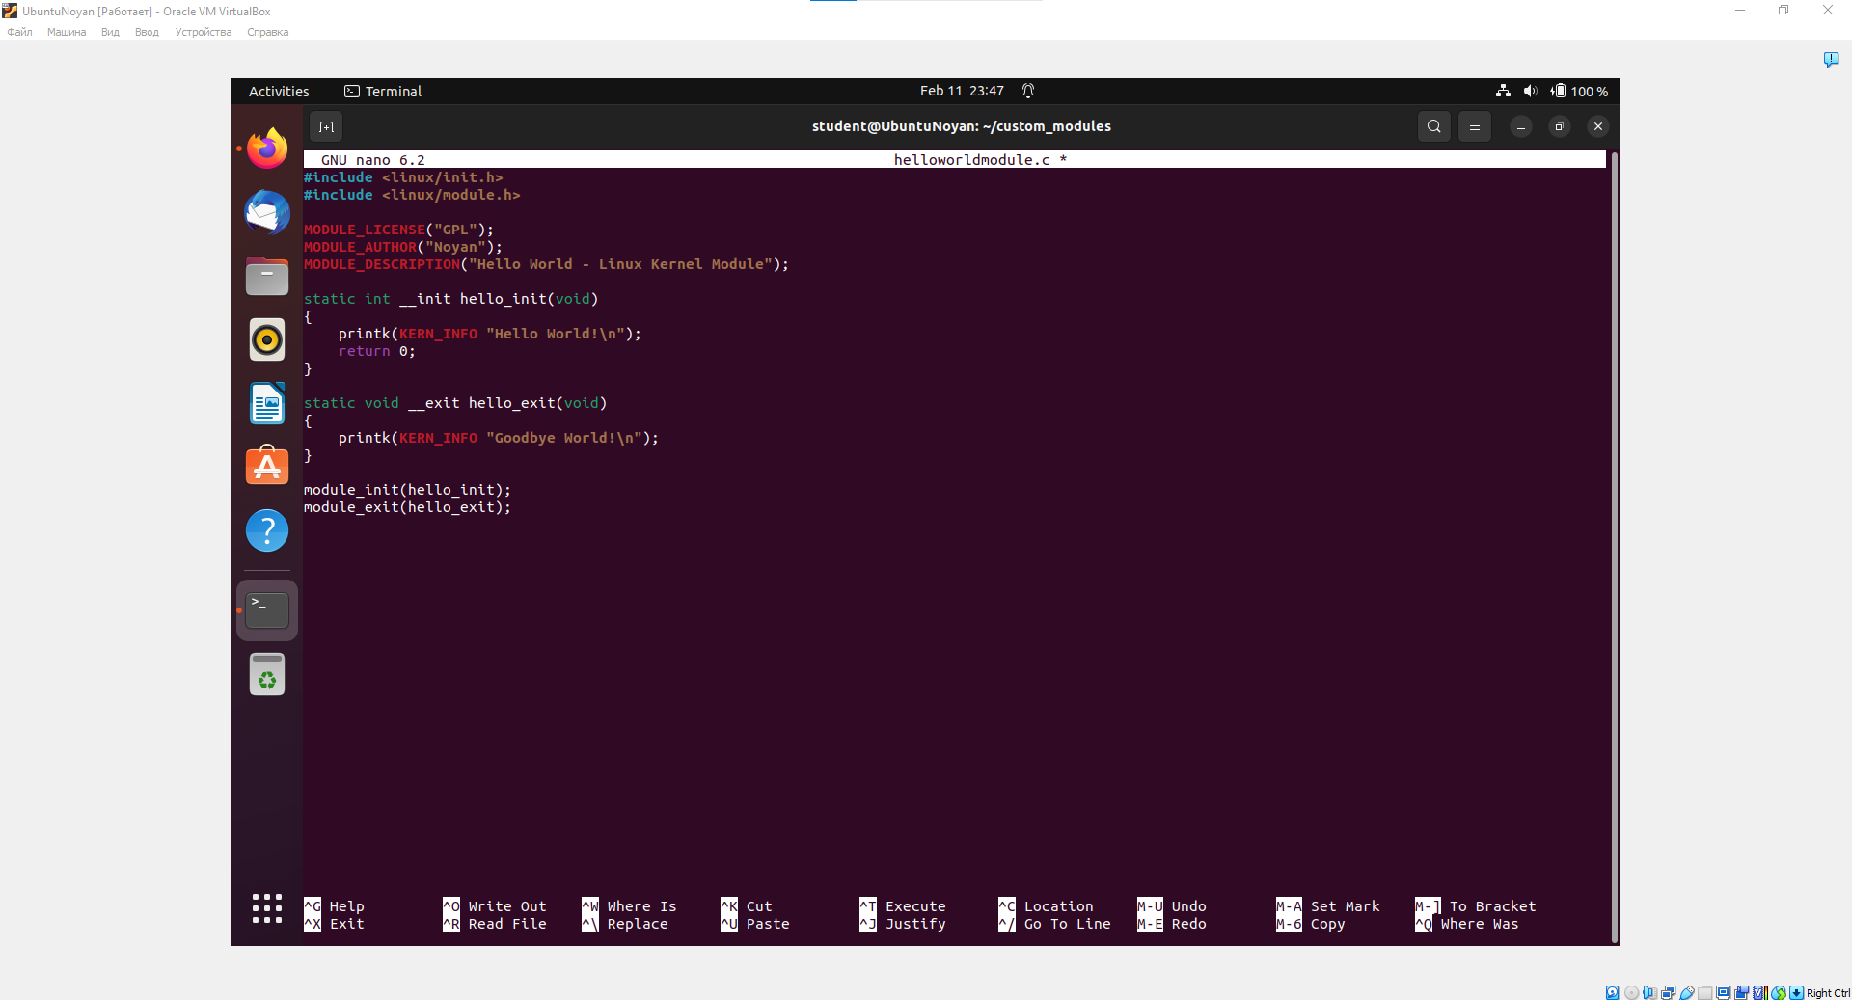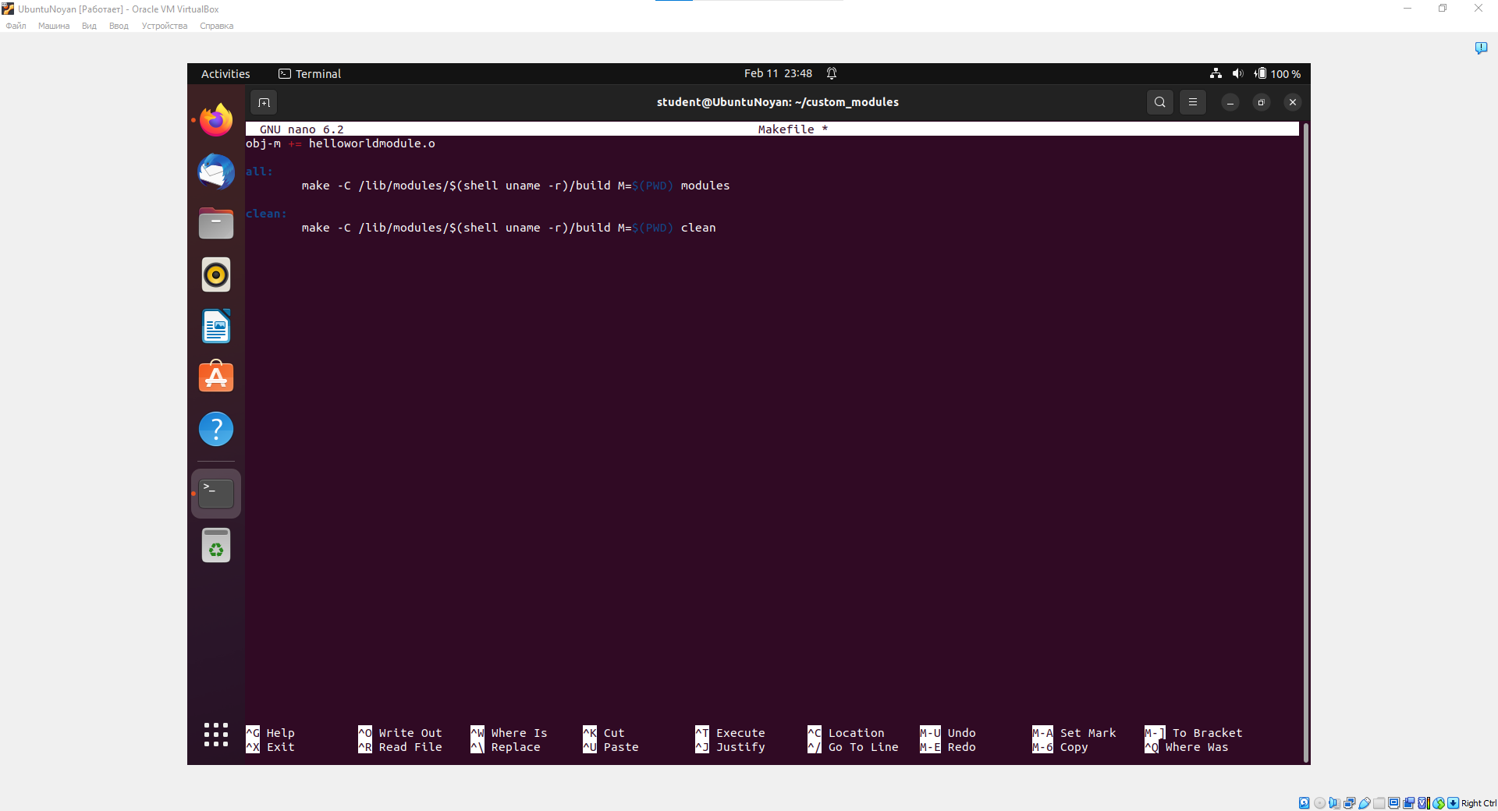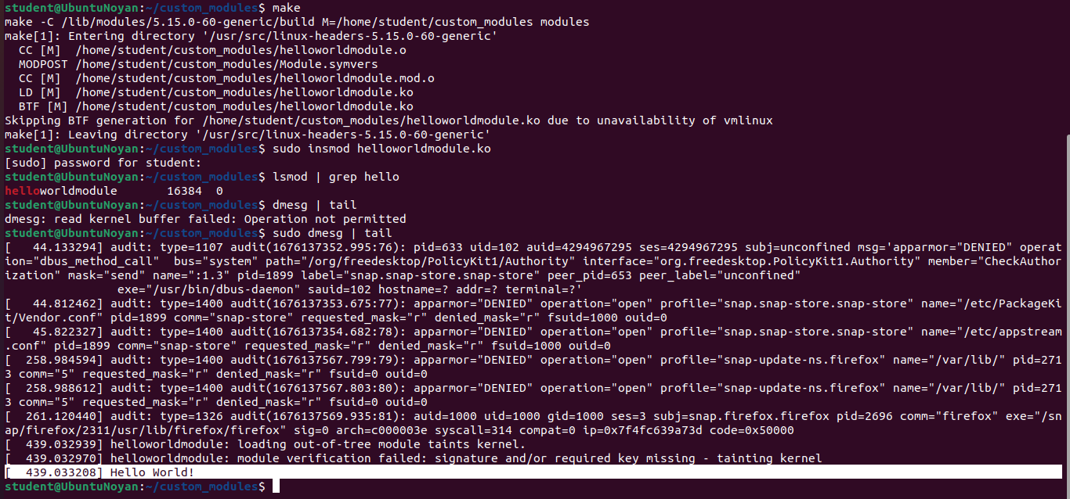

Picture 3. “Hello World Module” – writing hello world when active in kernel. helloworldmodule.c – our kernel module; Makefile – compiler for helloworldmodule.c; sudo insmod helloworldmodule.ko - load the module into the kernel, etc; lsmod | grep (module name here) – finding our specific module in kernel; dmesg | tail – checking kernel buffer to find callbacks of our module;

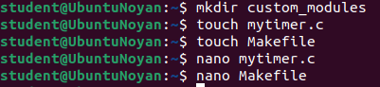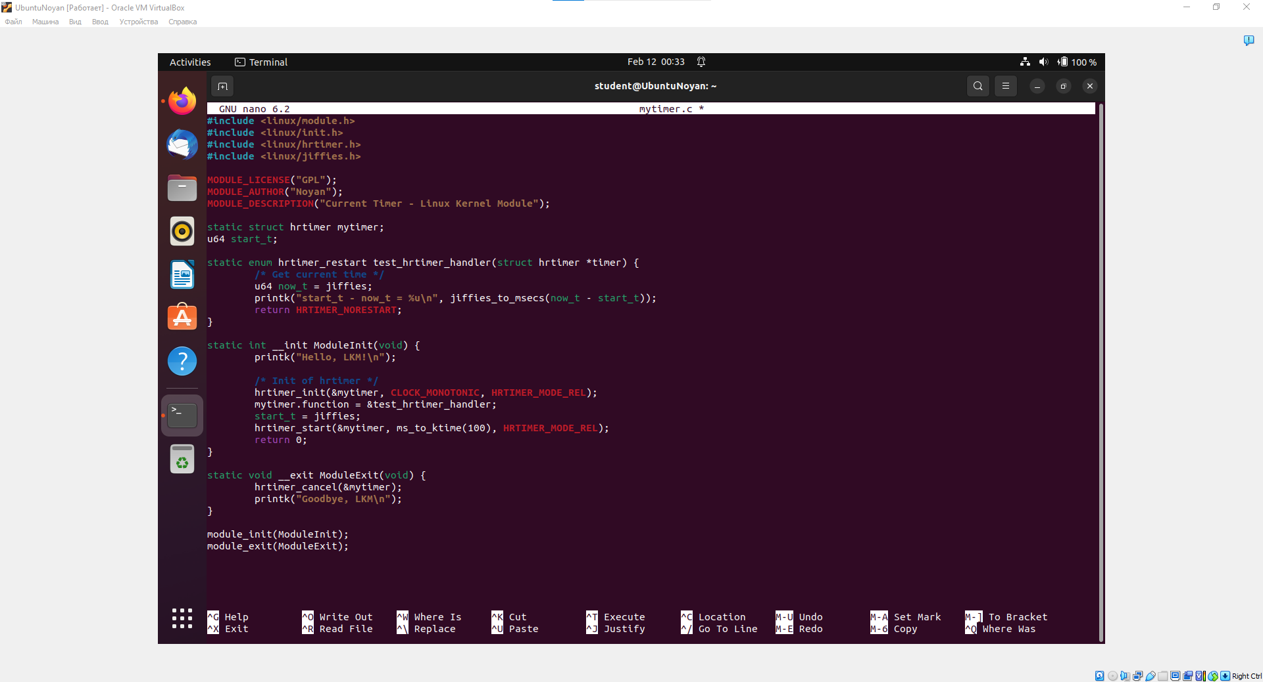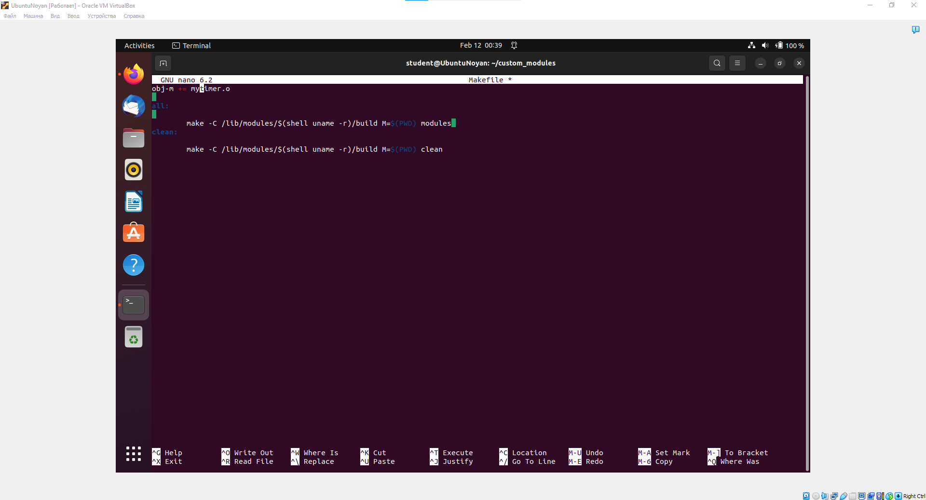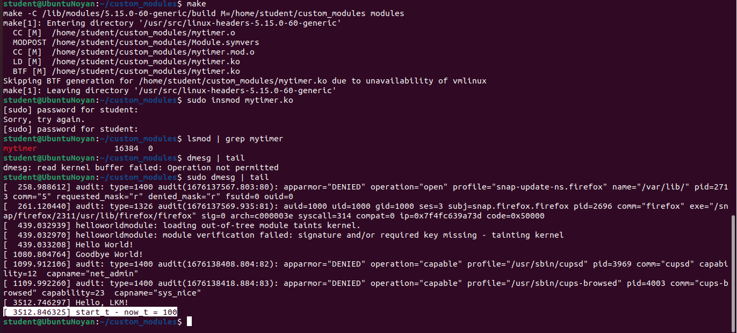

Picture 4. “Current Timer Module” – calculating timings for specific boundaries of time. mytimer.c – our kernel module; Makefile – compiler for mytimer.c; sudo insmod mytimer.ko - load the module into the kernel, etc; lsmod | grep (module name here) – finding our specific module in kernel; dmesg | tail – checking kernel buffer to find callbacks of our module;

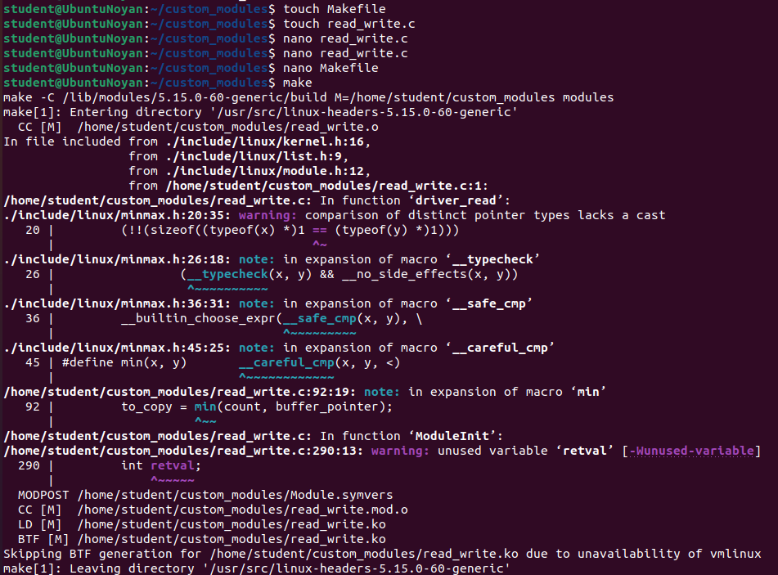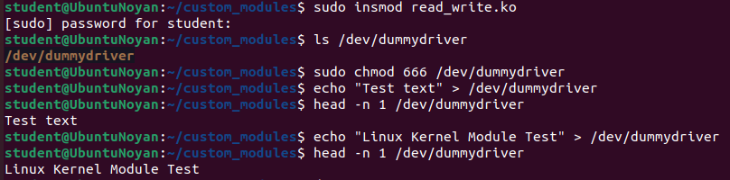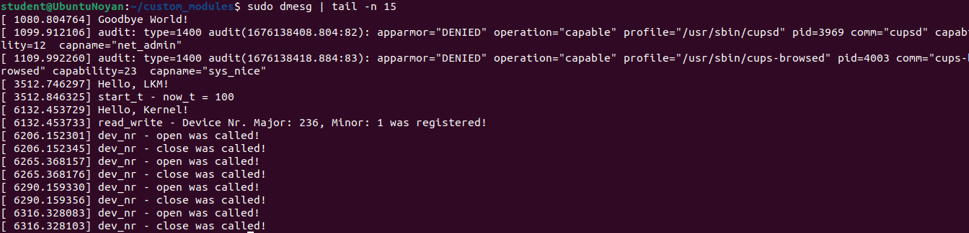

Picture 5. “Imitation Device Callbacks” – writing about all changes or accesses in /dummydriver and its Nr in devices. read_write.c – our kernel module; Makefile – compiler for read_write.c; sudo insmod read_write.ko - load the module into the kernel, etc; lsmod | grep (module name here) – finding our specific module in kernel; dmesg | tail – checking kernel buffer to find callbacks of our module;

**3. Conclusion**

**3.1. Reflection and summary**

We made hard work and finished our final project for OSC. This process of adding new user to OS, making connections to the internet via different methods, building Linux OS Kernel with Kernel modules are essential skills for our future as cybersecurity specialists or system administrators.

We gain a greater grasp of the Linux kernel and its operations by creating a Linux OS kernel module. This can be helpful for creating unique drivers, expanding the kernel's capabilities, and comprehending how the kernel and hardware communicate.

In conclusion, completing these activities has helped us comprehend the various elements needed in administering a Linux system. Each stage, from managing users to connecting to the internet, calls for a specific level of expertise and comprehension of the underlying systems and protocols. We have learned a lot from this experience and have a better understanding of how these ideas are used in the actual world.

**4. References and bibliography materials**

Squid Proxy - <http://www.squid-cache.org/>

The Linux Kernel Module Programming Guide - <https://sysprog21.github.io/lkmpg/>

Docs of Linux Kernel - <https://docs.kernel.org/>

Microsoft Azure for proxy server deployment - <https://azure.microsoft.com>